Event: Scottish Team Racing Championships

DATE: 07/03/2025 - 09/03/2025

SAILING INSTRUCTIONS

Addendum A: Event Specific Rules

A1: Additional Rules
A1.1 RRS D2 applies. Races will be umpired. | Yes
A1.2 RRS 20 is changed. The Arm Signals in RRS D1.1(d) are required. | No
A1.3 (1) A boat capsized after her starting signal, with her masthead in the water, shall retire promptly.  (2) A boat capsized after her starting signal, with both gunwales touching the water or her mast stuck in the bottom, shall retire promptly. | 1
A1.4 Providing the flag remains on the mark, a boat may touch any part of the flag of a mark that does not surround the staff of the mark. This changes RRS 31. | Yes
A1.5 RRS 40 (Personal Flotation Device) applies at all times while afloat. | Yes
A1.6 Competitors shall wear a wet or dry suit at all times while afloat. | No
A1.7 Spinnakers, trapezes and the gear specifically provided for the utilisation of these shall not be used. | n/a
A2: Course and Marks, Starting Signals, Prohibited Areas, Other Local Rules
A2.1 The course will be S course, each as defined in Addendum C.
A2.2 The visual starting signals will be battens
The times of starting signals will be: 3,2,1 .
A2.3 The course marks will be described during the competitors briefing on Friday morning before racing.
A2.4 The following are prohibited areas that a boat shall not enter or cross. They rank as obstructions: shallow areas, pontoons and any other valid obstruction as described at Friday morning competitors briefing before racing or See Addendum N
A2.5 Local rules will be detailed during the Saturday morning competitors briefing before racing or are detailed in Addendum N
A3: Communication with Competitors
A3.1 The location of the Official Noticeboard is the: BUSA/KSail Results Website, event WhatsApp group or local location as stated at briefing.
A3.2 Signals made ashore will be displayed on the Official Noticeboard or at an alternative location specified at the competitors briefing.
A4: Intended Format -
Format codes, and the format and scoring rules that apply for each, are stated in Addendum B.
Stage | Format Code | Additional Information
1 | H | HLS league. Scoring set by Addendum H. Top half (rounded up) to Gold in stage two, next half to Silver.
2 | Groups | Round-Robin(s) in two Groups (Gold and Silver)- seeded by stage one. Scoring set by RRS D4.3 and D4.4.
3 | KO | Knock out stage - Repechage (1 race) between 4th in Gold and 1st in Silver. Winner (or if stage 3 not sailed, 4th in Gold) to Stage 4. Under RRS D4.2(b) a quarter final stage may replace stage three, details will be shared via the Official Notice Board.
3 | KO | Knock out stage - semi-finals: Gold 1st v stage 3 winner or 4th gold & Platinum 2nd v Platinum 3rd. First to score 2 race wins.
5 | KO | Final, first to score 2 race wins.  Petit-final, first to score 2 race wins.
A5: Other Addenda that Apply –
K: Supplied Boats | X | L: Boat handling Rules | X | M: Breakdown Delays | X | N: Other Rules | X

UKTRA EVENT SAILING INSTRUCTIONS

Rules
  - Racing will be governed by the rules as defined in the Racing Rules of Sailing (RRS) including Appendix D, Team Racing Rules. Competitors should note that the current version of rule D1.2(a)(1) concludes: ‘… contact between boats on the other team’.
  - Add to RRS D2.3 “(g) breaks SI 6.1, A2.4 or a rule in SI Addendum L (if applicable)”. Breaches of these rules may therefore be penalised by the umpires without a protest.
  - Addenda A, B and C to these Sailing Instructions (SIs) always apply. Other addenda apply only when stated in SI A4 (Format Code) or A5. Green text is for guidance only.
  - The right of appeal is denied in accordance with RRS 70.3(b).

Eligibility and Registration
  - To become eligible a team shall register as required by the Notice of Race or, if not specified, on arrival at the event.
  - After registration, a team member may only be changed with the prior consent of the race committee, which will only be given when the team member is unexpectedly unable to sail.

Communication with Competitors
  - Notices to competitors will be posted on the Official Noticeboard (ONB). SI A3.2 states where signals made ashore will be displayed or communicated.
  - Changes to these SIs will be posted on the ONB not less than 10 minutes before the warning signal of the first race affected.

Event Format and Schedule of Races
  - The intended format of the event is described in SI A4.
  - The schedule of races will be displayed on the ONB. Any changes, and schedules for subsequent races, will be displayed not less than 10 minutes before the start of those races.
  - Every race will be assigned a race number in the race schedule.
  - The number of the next race to start will be displayed on the starting vessel from before, or promptly after, the warning signal until the starting signal. The race committee may at any time postpone a race and reschedule it at a later time.
  - When a race has been abandoned and the result would not affect which teams qualify for a further stage, the race committee may choose not to re-sail the race.

Starting Signals, Starting Marks and Finishing Marks, Starting Procedure
  - The visual starting signals and times are specified in SI A2.2. The sequence will be:
Signal meaning | Minutes before starting signal | Sound Signal | Visual signal
Signal meaning | Minutes before starting signal | Sound Signal | Flags | Battens or Shapes
Warning | 3 | One | Class flag up | 3 displayed
Preparatory | 2 | One | Flag P up | 2 displayed
One-minute | 1 | One | Flag P down | 1 displayed
Starting | 0 | One | Class flag down | None
  - Attention may be drawn to an imminent warning signal by a series of short sound signals.
  - Starting signal times shall be taken from the start of each sound signal. The failure of a visual signal shall be disregarded. This changes RRS 26.
  - When the starting signal is also the warning signal for the next race, the class flag will remain displayed, or 3 battens or shapes will be displayed.
  - The starting line will be from the mast of a committee vessel and the nearby starting mark. The finishing line will be from the mast of a committee vessel and the nearby finishing mark.
  - When a boat is subject to RRS 29.1, flag X need not be displayed for longer than 1 minute after the starting signal; this changes RRS 29.1. The race committee may hail the sail numbers or the total number of premature starters.
  - A boat shall not start more than 2 minutes after her starting signal.
  - After a general recall, succeeding races may be delayed for the recalled race. Attention is drawn to SI 4.4.

Event Continuity
  - A boat shall not be sailed in a manner that is likely to cause damage.
  - Before starting and after finishing or retiring, boats shall sail to minimise any delay to the race schedule and without interfering with any race in progress.
  - The race committee may move a mark at any time. RRS 27.2 and RRS 33 are deleted.
  - The time limit for a race will be 30 minutes.

Protests, Requests for Redress, Scoring and Penalties
  - Protests and requests for redress that have not been decided afloat shall be notified to the race office within 10 minutes after the relevant incident or, if the incident is afloat, within 10 minutes after coming ashore.
  - When the outcome of a protest or request for redress would not affect which teams qualify to a later stage, the protest committee may refuse to hear it. This changes RRS 63.2(a).
  - When the race umpires decide that a boat has broken RRS 14 and there is damage or injury, they may penalise her team by half a race win without a hearing. The boat will be informed as soon as practical and may request a hearing. Any penalty after a hearing will be in accordance with RRS D3.3(a).
  - When a boat breaks SI A1.3 or 5.7, 6 points shall be added to her score without a hearing.
  - When a competitor breaks RRS 40 or SI A1.6 (wet or dry suits), the race committee may penalise the competitor's team half a race win without a hearing.
  - After a hearing, the penalty for a breach of a rule, other than a rule of RRS Part 2, RRS 31 or RRS 42, that has had no effect on the outcome of a race, shall be at the discretion of the protest committee, and may be no penalty. This changes RRS D3.3.

Risk Statement
  - Rule 3 of the Racing Rules of Sailing states: "The responsibility for a boat’s decision to participate in a race or to continue racing is hers alone."
Sailing is by its nature an unpredictable sport and therefore inherently involves an element of risk. By taking part in the event, each competitor agrees and acknowledges the risk statement included in the Notice of Race. If the Notice of Race does not include a risk statement, the RYA Risk Statement in Addendum A to Appendix J of the RYA publication of the RRS shall apply.

Index to SI Addenda
Addenda That Always Apply
A Event Specific Rules
B Event Format
C Courses
Other Addenda
K When Boats are Supplied by the OA
L Keelboat Rules
M Change of Format due to Breakdown
N Additional Rules, including local rules
Race Formats, Schedules & Tie-breaks
E Round-Robins in Groups
F Random Pairs
H HLS League
G Swiss League
J Special Event Format (provided by RC)
Addendum B: Event Format
The intended format for each stage of the event shall be stated in SI A4, selected from the following standard formats, or from an Addendum J provided by the race committee and included with these Sailing Instructions. The race committee may change the format as provided in RRS D4.2(b).
Code | Description | Format & Scoring Rules
Groups | Round-robin(s) in group(s) | RRS D4.3, D4.4, and Addendum E
Random | Random pairs (2-boat teams only) | Addendum F
HLS | HLS league | Addendum H
Swiss | Swiss league | Addendum G
RC | Other format provided by race committee | Addendum J
KO | Knock-out | RRS D4.5
The specified addendum for each format contains the necessary race schedules, or procedures to create the schedules, together with rules which shall apply for scoring and breaking ties.
For each stage, any assignment of teams to groups or matches, and the method of qualification for the next stage, shall be stated as ‘Additional Information’ in SI A4.
For a Round-Robin stage, the intended number of round-robins in the stage shall be stated. Any carry-forward of wins from a previous stage, weighting applied to scores from an earlier stage, or change to the percentage in RRS D4.3(b) shall also be specified.
Any For a Knock-Out stage, RRS D4.5 requires the number of race wins required to win a match to be stated. If not stated the winner shall be the first team to score two race wins. A knock-out stage may be preceded by a one-race repechage between two teams to decide the last qualifier.

Addendum C: Courses
C1 'S' Course
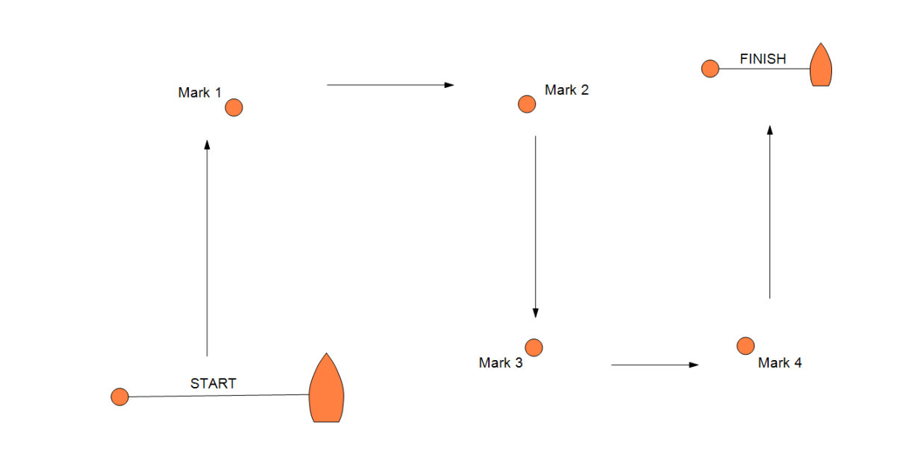
Course: Start, round marks 1 then 2 to starboard, round marks 3 then 4 to port, finish.
C2 Box Course
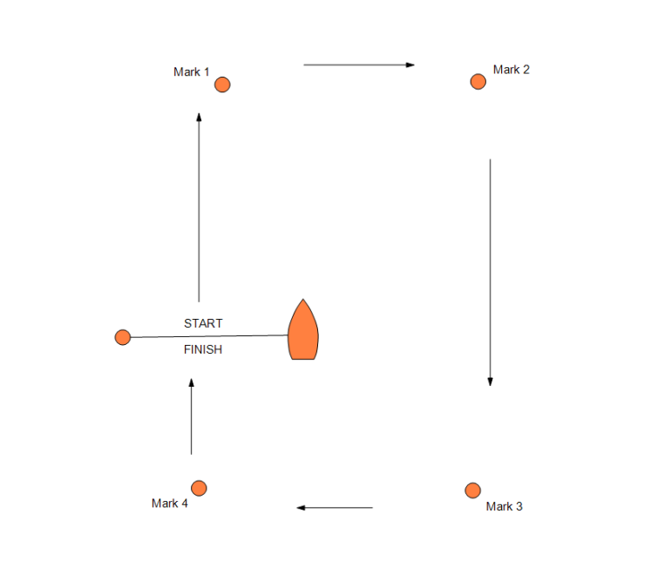

Course: Start, round marks 1, 2, 3 and 4 in that order, finish.
Unless stated otherwise in SI A2.1, marks are rounded to starboard.
On Leg 3, all start and finish marks shall be passed on the same side as the marks, and boats shall not cross the start or finish line, which rank as obstructions.

C3 Other Course
As displayed on the official notice board.

Addendum E: Round-Robins in Groups
E1 In the first stage of an event, the teams shall be assigned to a single group, or to multiple groups randomly or with seeding based on past performance.
E2 Unless stated otherwise, in a second round-robin stage, the highest placed teams shall be assigned to the Gold group, the next highest placed teams to the Silver group, and so on.
E3 RRS D4.3 and D4.4 define the scoring for a Round-Robin stage.
Addendum F: Random Pairs
F1 Boats (ideally a multiple of 4) enter and shall be scored individually, but in each race shall be paired up to sail with one other boat against another team of two boats.
F2 Each boat in the winning team of a race shall score one race win. Each boat in the losing team shall score zero race wins.
F3 Boats shall be ranked in order of number of race wins, highest first, or, if boats have not completed an equal number of races, in order of the percentage of races won.
F4 Ties shall be broken using RRS D4.4 with D4.4(a) changed as follows:
(a) If the tied boats have all sailed each other at least once, the tie shall be broken in the order below:
(1) percentage of races won in all races between the tied boats, highest first;
(2) average team points per race in all races between the tied boats, lowest first;
(3) if two boats remain tied, the winner of the last race between them;
(4) average team points in all races, lowest first;
(5) if the tie needs to be broken, a game of chance.
Addendum H: HLS League

H1 Teams for each race will be selected randomly. A team will not sail any other team more than once in a stage.
H2 If the full round robin has been completed, teams shall be ranked on the basis of RRS D4.3(a) and ties broken using RRS D4.4.
H3 If the full round robin has not been completed, teams shall be ranked in order of their percentages of races won. RRS D4.3(b) is deleted, and RRS D4.4 is changed to:
(a) Ties shall be broken in the following order in favour of:
    - if all tied teams have met, the number of races won when they met, highest first;
    - if all tied teams have met, the total points scored when they met, lowest first;
    - the average points per race scored by each tied team in all its races, lowest first;
    - the average of the percentage wins of teams that each tied team beat, highest first;
    - the average of the average points scored in all races by teams that each tied team beat, lowest first;
    - a sail-off if possible, otherwise a game of chance.
(b) If a tie is partially resolved by one of the above, then the remaining ties shall be broken by starting again at D4.4(a)(1).
H4 In order for H3 to break ties as fairly as possible, when a team is penalised a race win (or part thereof) for an incident when not racing, the team's total points score shall also be increased by 6 points (or 3 points) respectively. Individual race scores are not changed.

Addendum G: Swiss League
G1 A draw will determine the first round.
G2 The second round will be using the order of the original draw, the first winner against the second winner and so on, except the first loser will sail the last loser or the last winner.
G3 Rounds will then be scheduled at the conclusion of a round for the next round but one by ordering the teams, using the tie-breaks below, and then matching them as far as possible in order of their places (the first team will sail the second team and so on), except that teams shall not be matched if they have met within a specific number of rounds. The default is 8; if not 8, the number shall be stated in A4.
G4 If the final round is not completed, its results will be ignored.
G5 Races that cannot be sailed in order, or for which results are not entered or complete, will be ignored for scheduling purposes. Subsequently corrected or altered results shall not affect a published schedule.
G6 A ‘drop-out’ is a team unlikely, in the opinion of the race committee, to take any further part in the event. The decision to designate a team as a drop-out will be posted, after which its races will continue to be scheduled but will not be sailed and opponents shall score a win. Drop-outs will be scheduled from the first unscheduled round after dropping out, first against each other and then, where possible, against the lowest-placed team the drop-out has not met. Drop-outs may re-join the event at the discretion of the race committee whose decision will be final.
G7 Any other missing team is a no-show and the opposing team shall be given a walk-over after at least one of its boats has started and sailed for two minutes.
G8 Resails will be scheduled at the end of the next available round using the original race number. They will not necessarily be in the same boats as the original race.
G9 Half-win penalties shall be applied after the end of the round and before tie-breaks are applied.
G10 Ties shall be broken, in order of precedence, in favour of the team(s) that has:
- if the tie is between two teams only, won the last race between them;
- sailed more races against teams that have a higher place;
- sailed fewer races against teams that have a lower place;
- the lowest sum of the places of the teams the tied teams have beaten;
- the lowest sum of the places of the teams to which the tied teams have lost;
- beaten the highest-placed team the tied teams have individually beaten;
- not been beaten by the lowest-placed team to which the tied teams have individually lost.
Step (a) shall be applied whenever a step leaves a tie between two teams.
Steps (b) to (g) shall be repeated until no more ties can be broken. Any remaining ties shall then be broken by the draw for the first round; ties in odd-numbered rounds shall use the draw, ties in even-numbered rounds shall use the draw inverted.

Addendum K: When Boats are Supplied by the Organising Authority
K1 EQUALISATION AND ALLOCATION
- The organising authority and race committee will take reasonable steps to equalise the boats.
- The race committee will allocate the boats to be used in each race.
- Neither the allocation of boats, nor any variation between the boats and their equipment, shall be grounds for redress. This changes RRS 61.4(b).
K2 (a) Supplied boats shall be deemed to conform to their class rules.
(b) When class rules change RRS 42, such changes shall not apply.
K3 RESPONSIBILITY FOR A BOAT
- A boat shall remain the responsibility of the team until handed over to the race committee or the next team to use that boat. Boats shall be handed over as empty of water as practical and in racing trim.
- Competitors are responsible for inspecting their boats before racing.
- Competitors shall report any defects, damage or breakdown to the race committee at the first reasonable opportunity.
- When to continue racing after damage or a breakdown risks further damage to the boat, she shall retire immediately.
K4 PROHIBITED ACTIONS
(a) Adjusting or altering the tension of standing rigging, excluding the backstay when fitted, except with the authorisation of the race committee;
(b) Adding to, omitting or altering the equipment supplied, including cutting or shortening any sheets, control lines or other running rigging;
(c) Removing or replacing any equipment without the consent of the race committee;
(d) Marking directly on the hull or deck with permanent ink;
(e) Perforating sails, even to attach tell tales;
(f) Boarding or using a boat without the consent of the race committee.
K5 REQUIRED ACTIONS AT END OF EACH DAY
At the end of each sailing day, the crew shall complete the following tasks:
    - Sails shall be rolled, bagged and placed as directed.
    - The boat shall be left in the same state of cleanliness as when first boarded that day.
    - The crew shall comply with any directions posted on the boats or otherwise given to the crew by the race committee.
    - The boat shall be returned to the dock or other notified location and secure it safely in accordance with any local instructions.
At the end of the final day for a particular boat, the boat shall be cleaned, and all rubbish, tape and marks removed.

Addendum M: Change of Format due to Breakdown

M1 If races in a 3v3 event are likely to be unduly delayed by a boat being repaired or replaced, the race committee may act under D4.2(b) and designate some races to be raced by teams of 2 (i.e. 2v2) until there are sufficient boats to resume 3v3.

M2 Teams will be notified of this change orally, either ashore, or by the start boat or umpires on the water. The teams may choose which of their three helm-crew pairings does not race.

M3 For the purposes of scoring, the team winning the race shall have 5 points (equivalent to its third boat finishing in 5th place) added to its score, and the team losing the race shall have 6 points added to its score.

