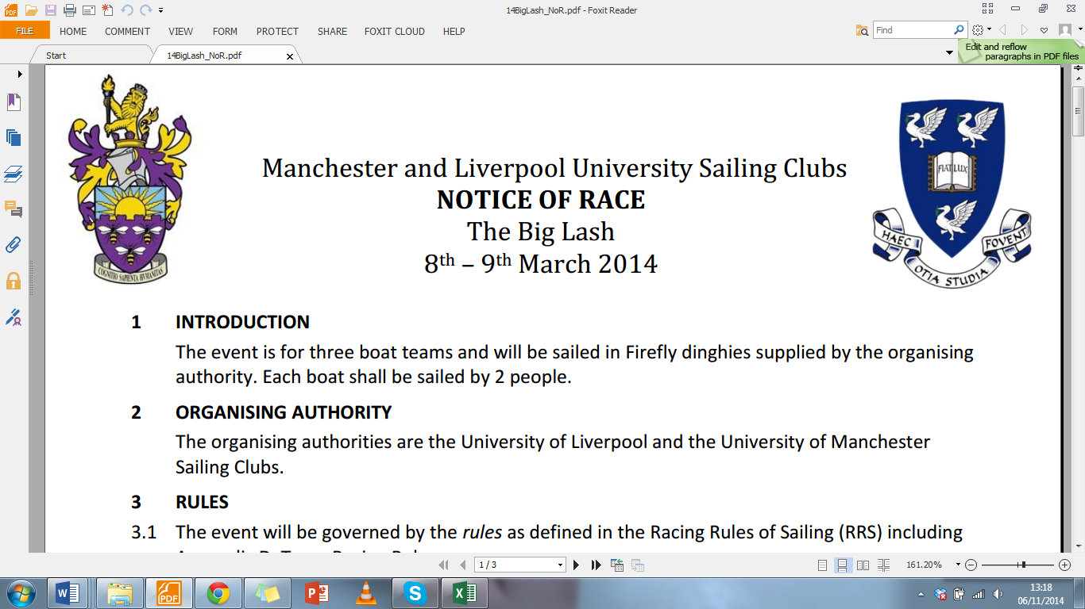
University of Liverpool Sailing Club and University of Manchester Sailing Club
NOTICE of RACE
The Big Lash
22nd and 23rd March 2025

1 | INTRODUCTION
 | The event is for three boat teams and will be sailed in Fireflies supplied by University of Liverpool SC and West Kirby SC. Each boat shall be sailed by 2 people.
2 | ORGANISING AUTHORITY
 | The organising authority is University of Liverpool SC (LUSC) and University of Manchester SC (UMSC), and thank West Kirby Sailing Club (WKSC) for hosting. Their club rules will apply at this event.
3 | RULES
3.1 | The event will be governed by the rules as defined in the Racing Rules of Sailing (RRS) including Appendix D, Team Racing Rules.
3.2 | Races will be umpired.
3.3 | The Sailing Instructions will be published in a separate document before the event and available to all competitors. These change some rules in the RRS.
3.4 | In accordance with RRS 70.5(a) the right of appeal will be denied.
3.5 | While attending and competing in the event, any competitor will be a temporary member of WKSC and must obey the relevant rules and regulations.
4 | ENTRIES AND DEPOSIT
4.1 | Entries are invited from all teams.
4.2 | The closing date for receipt of entries and payment of the entry fee is 12:59 Friday 7th March 2025. Late entries may be considered at the discretion of the Organising Authority.
4.3 | The entry fee will be £350 per team.
4.4 | If this event is oversubscribed, teams will be selected based on their sailing CV. The event organisers reserve the right to deny teams without explanation. There will be a maximum of 24 teams at the event.
4.5 | If a team pulls out of the event after 23:59 Friday 7th March 2025, and neither they nor the Organising Authority are unable to find a replacement team, they may not be refunded the full entry fee.
4.6 | In the event that the Organising Authority is forced to cancel the event, then teams will still be required to pay costs for the event.
4.7 | Each team will be liable for the cost of damage to boats, equipment and property up to a maximum of £300 per incident. This includes, but is not limited to, damage occurring at West Kirby Sailing Club, University of Liverpool, University of Manchester, social venues, and any host accommodation - both during racing and social events. A deposit for this amount will be required at registration and before a team may sail. This will be via a signed form. When a team is assessed as liable for damage, it shall restore the deposit to the original value in order to continue sailing. Damage attributed to competitors generally or to an unidentified team will be attributed equally between all relevant teams, at the discretion of the umpires and Race Committee. A team may apply to the Protest Committee to determine their responsibility for any damage.
5 | EVENT FORMAT AND SCHEDULE
5.1 | The format of the event will be round robins followed by semi-finals, and finals.
5.2 | Registration will take place at West Kirby Sailing Club from 8.30am Saturday 22nd March
5.3 | There will be a briefing at 9.00am on 22nd March 2025 at West Kirby Sailing Club.
5.4 | The first warning signal will be at 9.30am
5.5 | The final warning signal will be no later than 17:00 on Sunday 23rd March. This can be changed within 1 hour of the time by the PRO
6 | BUOYANCY AND CLOTHING
 | Adequate personal flotation devices and wet or dry suits shall be worn by all competitors at all times when afloat.
7 | RISK STATEMENT, INSURANCE
7.1 | Rule 4 of the Racing Rules of Sailing states: "The responsibility for a boat’s decision to participate in a race or to continue racing is hers alone."  Sailing is by its nature an unpredictable sport and therefore inherently involves an element of risk. By taking part in the event, each competitor agrees and acknowledges that:  (a) They are aware of the inherent element of risk involved in the sport and accept responsibility for the exposure of themselves, their crew, and their boat to such inherent risk whilst taking part in the event;  (b) They are responsible for the safety of themselves, their crew, their boat, and their other property whether afloat or ashore;  (c) They accept responsibility for any injury, damage or loss to the extent caused by their own actions or omissions;  (d) Their boat is in good order, equipped to sail in the event and they are fit to participate;  (e) The provision of a race management team, patrol boats and other officials, and volunteers by the event organiser does not relieve them of their own responsibilities;  (f) The provision of patrol boat cover is limited to such assistance, particularly in extreme weather conditions, as can be practically provided in the circumstances.
8 | PRIZES
 | These will be awarded at the discretion of the organising authority.
9 | PRIVACY STATEMENT  The personal information you provide to the organising authority will be used to facilitate your participation in the event. If you have agreed to be bound by the Racing Rules of Sailing and the other rules that govern the event (the rules), the legal basis for processing that personal information is contract. If you are not bound by the rules, the legal basis for processing that personal information is legitimate interest. Your personal information will be stored and used in accordance with the organising authority’s privacy policy. When required by the rules, personal information may be shared with the RYA, your national authority, and/or World Sailing. The results of the event and the outcome of any hearing or appeal may be published.
For further information please contact:

Liverpool University - unioflivsailing@gmail.com , Thomas Donald 07470038071

Manchester University - sailing@manchester.ac.uk , Harry Penman +44 7757 408526

