Wessex Winter Warmer Welcome Pack

We are pleased to welcome you to the 2026 Wessex Winter Warmer, which is occurring on the 24th and 25th of January! This document has been provided to supply you all with further information about the event. Please make sure you have read the NOR, SI and other documents all available on the KSail website as well as this one.

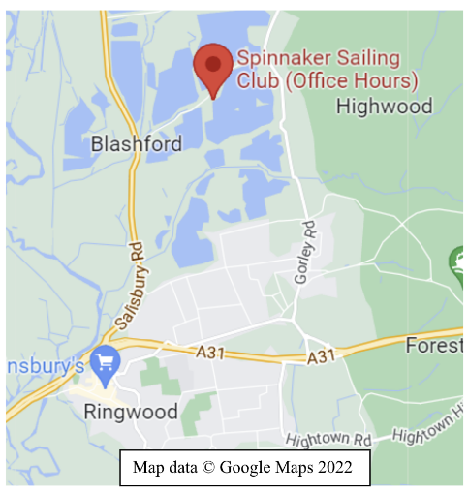
Venue and Event Information
Arriving at Spinnaker Sailing Club:

Spinnaker Sailing Club is based on Ivy Lane,
Blashford, BH24 3LY. Ivy Lane is just off the
A338 Salisbury Road, about 5 minutes from
Ringwood. Please be aware that Ivy Lane
itself is a narrow road with passing places.
It should also be noted that as you turn into the club grounds from Ivy Lane, you will be
crossing a Long Distance National Footpath
that is heavily used. Once on the Club’s
driveway and throughout the Club’s site
there is a 5mph speed limit.

Please find below the map of the sailing club and facilities. When you arrive at the front gates, take a left along a gravel path to take you to the Team car park.

The club house itself has a range of facilities to use during the weekend. There is both a gents and ladies changing room and toilets. The galley will be open through the event selling teas and coffees. The club house is also a place to wait between races to keep warm.

A burger van will be on site throughout the weekend. They will be serving breakfast from 8:30 and lunch through the day. This will be located next to the club house in the officials’ parking.

The burger van will accept card payments, but please bear in mind that hot drinks in the galley may be cash only.
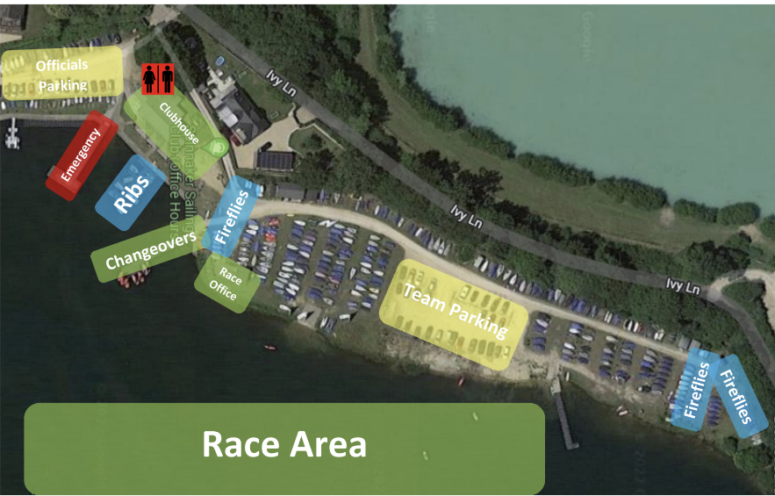

You can find the sailing instructions and more information about the event on the official notice board, which can be found at the following link:
https://events.ksail.co.uk/2026/Warmer/

Damages

This year we are adopting a different approach to damages. We are using the KSail online damages deposit system, linked here https://help.ksail.co.uk/portal/en/kb/articles/online-damage-deposit-service#How_does_the_service_work. This can be done from midday on Friday through to registration at the event. I (Charlotte) will be able to see who has completed this pre-authorised payment method and if this is not completed before sign in on Saturday, you will be asked to complete this before you can race.

Schedule
Saturday
Registration | 8:15
Briefing | 8:45
First Warning Signal | 9:27
Sunday
First Warning Signal | 8:57
Knock outs | Around 14:30

Entry List
Team Name
Exeter Blue
The Stern Thrusters
Cambermet Cardinals
Wessex Wombles
RLYC FOXES
Royal Lymington YC
Sloan Rangers
Castaways
Cindies Sailing Club
Corinthian Tigers
Edinburgh Blue
Bonbonbonbons
West Mud Waders
Rutland Raiders
Wheatsheaf Wanderers
Southampton black
Trinity
UEA Yellow
Cumberland Sausages
Curious George

If you have any questions please contact events.sec.wessex@gmail.com or ring me on 07494575709.

