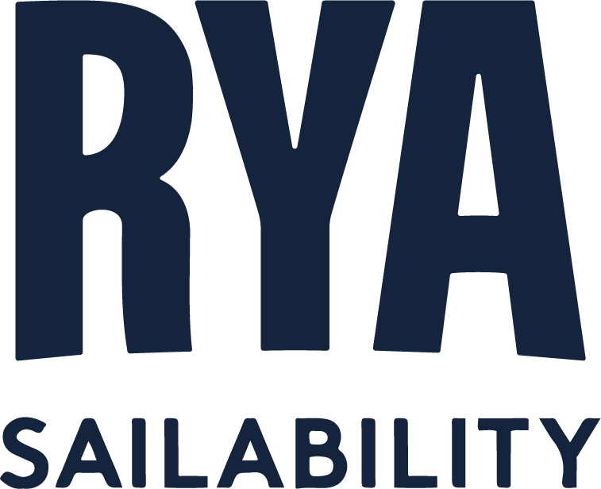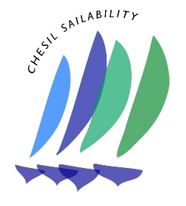 | 

Inclusive Games Keelboat League

Weymouth and Portland National Sailing Academy

Friday 17th to Sunday 19th July 2026

Notice of Race (NoR)

The Organising Authority (OA) is the Weymouth and Portland National Sailing Academy (WPNSA) supported by RYA Sailability & Chesil Sailability.

- RULES
  - The event is governed by the rules as defined in The Racing Rules of Sailing (RRS).
  - Races will be umpired; rule changes can be found in RRS Appendix UF.
  - The Organising Authority implements the Royal Yachting Association (RYA) Racing Charter. Competitors shall undertake to sail in accordance with the Charter.
  - The notation ‘[NP]’ in a rule means that a boat may not protest another boat for breaking that rule. This changes RRS 60.1.
  - RRS Appendix T (Arbitration) will apply.
  - [DP] RRS 40.1 applies at all times while afloat.
  - RRS 63.5(c) is changed so that in the event of a conflict between the Notice of Race and Sailing Instructions, the Sailing Instructions shall prevail.

- SAILING INSTRUCTIONS
  - The sailing instructions will be available on the online Official Notice Board, at least three days prior to the event.

- COMMUNICATION
  - The Official Notice Board is located online.
  - [DP] From the first warning signal until the end of the last race of the day, except in an emergency, a boat shall not make voice or data communication and shall not receive voice or data transmissions that is not available to all boats.

- ELIGIBILITY AND ENTRY
  - The event will be sailed in Elliot 6m keelboats (without spinnakers) supplied by the Organising Authority.
  - A minimum of four entries and a maximum of 12 entries will be accepted on a first come first served basis.
  - Late or additional entries may be accepted at the discretion of the OA.
  - The number of crew, including helm, for each Team is four. There are no weight limits.
  - There are no gender requirements for this event.
  - This an event for disabled people, sometimes sailing with non-disabled people. At least two crew shall identify as having a longstanding and limiting disability, impairment or long-term health condition.
  - Boats may enter the event online.
  - To be considered an entry for the event, a team shall complete all registration requirements and pay all fees.
  - The closing date for entries is midnight on Thursday 9th July 2026. Entries after this date are at the discretion of the Organising Authority, contact events@wpnsa.org.uk to request a late entry.
  - A Parent/Guardian Consent and Supervision Form must be completed by the Parent or Guardian of any competitor under the age of 18 on the first day of the event. This forms part of the online entry.

- FEES
  - The entry fee is £250 per team.
  - If a competitor cancels their entry, they will receive a full refund less a £25 administration fee for cancellations up to midnight on Sunday 5th July 2026. No refunds for cancellations after midnight on Sunday 5th July 2026.

- FORMAT OF RACING
  - The event consists of a number of short windward/leeward fleet races between a selection of entered Crews; with Crews sailing against every Crew as often as possible during an event.

- ADVERTISING
  - Boats may be required to display advertising chosen and supplied by the Organising Authority. See World Sailing Advertising Code.

- SCHEDULE
  - The Elliots will be available for Team practice in the afternoon on Friday 17th July 2026.
  - Registration will be from 15:00 to 17:00 on Friday 17th July 2026 in Room 6.
  - There will be a competitor briefing in the Event Hall at 09:00 on Saturday 17th July 2026.
  - The first warning signal will not be before 10:55 on Saturday 17th July 2026.
  - On the last scheduled day of racing, it is anticipated no warning signal will be made after 13:00.

- VENUE
  - The venue is the Weymouth and Portland National Sailing Academy, Osprey Quay, Portland, Dorset, DT5 1SA.
  - The racing area will be in Portland Harbour.

- COURSES
  - The courses to be sailed will be detailed in the Sailing Instructions.

- SCORING
  - Scoring Races will be scored using a High Point System as defined in the SI’s. There will be no discards.

- DAMAGE
  - By entering, Teams agree to be bound by the damage requirements as found in NoR Appendix X.
  - Damage costs attributed to competitors generally or to an unidentified team will be attributed equally between all teams.

- SUPPORT PERSONS VESSELS [DP]
  - All support boats will register with the Weymouth and Portland National Sailing Academy by completing an online Event Support Boat Registration Form at https://www.wpnsa.org.uk/event/event-support-boat-registration-form/. On arrival Support Persons shall report to the WPNSA Reception, before launching, to register and pay the fee of £15 per day (card payments only).
  - RRS 37 will be used. Except when responding to the signal in RRS 37, support boats, coaches and other support persons shall stay at least 100 metres outside areas where boats are racing from the time of the preparatory signal for the first class to start on that course until all boats have finished or retired or the race committee signals a postponement, general recall or abandonment.
  - During the event, support boats shall not tow boats participating in the event unless the race committee have signalled that towing is allowed.
  - In order to prevent fuel spillage, refuelling of boats/tanks is not permitted on the pontoons at WPNSA. Boats may refuel at the Portland Marina fuel pontoon or removable tanks may be taken offsite to be refuelled at a service station.
  - Kill cords shall be worn at all times whilst engines are running. The Course Safety Leader will be looking out for compliance on this issue, there are no excuses and boats will be requested to leave the race area immediately if kill cords are not being used appropriately.
  - All Support Boat drivers shall attend the Safety Briefing, details will be advised when registration form received.

- BERTHING
  - [DP] Boats shall be kept in their assigned spaces on the pontoons.

- DATA PROTECTION
  - The personal information you provide to the Organising Authority will be used to facilitate your participation in the event. If you have agreed to be bound by the Racing Rules of Sailing and the other rules that govern the event (the rules), the legal basis for processing that personal information is contract. If you are not bound by the rules, the legal basis for processing that personal information is legitimate interest. Your personal information will be stored and used in accordance with the Organising Authority’s privacy policy. When required by the rules, personal information may be shared with racingrulesofsailing.org, Our Club Admin, the RYA, your national authority and/or World Sailing. The results of the event and the outcome of any hearing or appeal may be published.

- RIGHTS TO USE NAMES AND LIKENESS
  - Competitors automatically grant to the Organising Authority without payment the right in perpetuity to make, use and show any motion pictures, still pictures and live, taped or filmed television of or relating to the event.

- RISK STATEMENT
Rule 3 of the Racing Rules of Sailing states: ‘The responsibility for a boat’s decision to participate in a race or to continue racing is hers alone.’

Sailing is by its nature an unpredictable sport and therefore inherently involves an element of risk. By taking part in the event, each competitor agrees and acknowledges that:

- They are aware of the inherent element of risk involved in the sport and accept responsibility for the exposure of themselves, their crew and their boat to such inherent risk whilst taking part in the event;
- They are responsible for the safety of themselves, their crew, their boat and their property whether afloat or ashore;
- They accept responsibility for any injury, damage or loss to the extent caused by their own actions or omissions;
- Their boat is in good order, equipped to sail in the event and they are fit to participate;
- The provision of a race management team, patrol boats and other officials and volunteers by the event organiser does not relieve them of their own responsibilities;
- The provision of patrol boat cover is limited to such assistance, particularly in extreme weather conditions, as can be practically provided in the circumstances;
- It is their responsibility to familiarise themselves with any risks specific to this venue or this event drawn to their attention in any rules and information produced for the venue or event and to attend any competitors briefing held for the event.

- PRIZES
  - Prizes will be awarded to the three highest ranked Teams.

- FURTHER INFORMATION
22.1 For further information please contact events@wpnsa.org.uk.

Appendix X – Damage

It is expected that all competitors show due care and attention to the boats that are provided for their use during the Series. Damage to boats causes conflict, delay and impacts everyone involved at the event. This attachment intends to help minimise damage whilst ensuring penalties are consistent; ultimately providing more racing at less cost for everyone.
This document explains how damage will be assessed and gives general guidance on the appropriate penalty. When the protest committee has good reasons to do so, it may apply a different penalty.

X1 Damage Agreement
X1.1 By entering the event, the team and all crew expressly agrees to follow and comply with this system without delay or dispute. A failure to comply with an instruction or invoice issued may result in disqualification from the event, series and future events without a hearing.
X1.2 Each skipper and crew are liable for up to £1000 of damage associated costs per incident (this includes boats, equipment and property).
X1.3 Any decision on the allocation and quantum of any damage associated costs is solely for the Organising Authority to determine. The Organising Authority may consider any recommendations of the Protest Committee. Subject to RRS 61, the decision of the Organising Authority is final and teams agree to accept it without dispute.

X2. Damage Assessment
X2.1 An initial assessment of the damage level will be made on the water as soon as possible following a racing incident using the table shown in X4 - Damage Levels.
X2.2 The initial assessment is for the purpose of Points Penalties only and is not linked to any damage associated costs which may subsequently be allocated to a Team. Onward assessment of the damage level after further inspection, whether the level turns out to be higher or lower, will have no effect on the points penalty given on the water but may affect any damage associated costs.

X3. Damage Levels
X3.1 The following table provides guidance on the scoring penalty which may be imposed on any boat subject to an Umpire decision under RRS 14 as changed in Appendix UF British Keelboat League Series 2025.

Damage Level | A | B | C
Damage Level | Minor Damage | Significant Damage | Major Damage
Points  Penalty | 2pts | 5pts | 10pts
Extent | Does not significantly affect the value, general appearance or normal operation of the boat. | Affects the value and/or general appearance of the boat | The normal operation of the boat is compromised, and its structural integrity may be  impaired.
Effect | The boat may race without repair although some minor surface work may be required after the event.  Repairs should not normally require more than 1 hour of work. | The damage does not affect the normal operation of the boat in that race but may need some (temporary) work before racing again.  Requires more than 1 hour of work but should not normally require more than 3 hours of  work. | The boat will need some repair work before racing again.  Requires more than 3 hours of work.

X4. Damage Associated Costs
X4.1 The Race Committee may require a team to make an intermediate payment, to the amount defined in this attachment; against allocated damage costs before the team may sail another event boat.
X4.2 If a team is allocated damage associated costs, and these are not paid at the event, the Organising Authority will issue an invoice to the team. Invoices must be paid (without set off or deduction) within 14 days unless an extension is agreed with the Organising Authority.
X4.3 Failure to comply with a damage invoice within 14 days (or any extension period) is a breach of this agreement and the Organising Authority may:
- add an administrative late payment fee of £30 per invoice;
- disqualify the team in question without a hearing;
- report the team members to the Protest Committee for investigation under RRS 69
- reject any future entries from the Club; Skipper; or crew in British Keelboat League Association linked events.
- Report the team to the British Keelboat League Association, their clubs and the RYA

The Organising Authority may amend or cancel a damage notice at any time and may reinstate a team disqualified.

